**上机三—构造函数和析构函数**

**一程序代码**

#include<iostream>

using namespace std;

class score

{

private:

int stu;

float sco[100][3];

string name[100];

public:

score()

{

stu = 2;

}

score(int stus1)

{

stu = stus1;

}

~score()

{

cout << "score destruction called!" << endl;

}

void inputstu()

{

int i;

for (i = 0; i < stu; i++)

{

cout << "请输入学生的姓名:" << endl;

cin >> name[i];

cout << "请输入科目A的成绩：" << endl;

cin >> sco[i][1];

cout << "请输入科目B的成绩：" << endl;

cin >> sco[i][2];

cout << "请输入科目C的成绩：" << endl;

cin >> sco[i][3];

}

}

void showstu()

{

int i;

for (i = 0; i < stu; i++)

{

cout << "姓名：" << name[i] << ' ' << "科目A：" << sco[i][1] << ' ' << "科目B：" << sco[i][2] << ' ' << "科目C：" << sco[i][3] << endl;

}

}

void stuavg()

{

int i, avg1;

for (i = 0; i < stu; i++)

{

avg1 = 0;

avg1 = (sco[i][1] + sco[i][2] + sco[i][3]) / 3;

cout << "姓名：" << name[i] <<' ' << "平均成绩：" << avg1 << endl;

}

}

void majave(string maj)

{

int i,j;

float avg=0;

if (maj == "A")j = 1;

if (maj =="C")j = 2;

if (maj == "B")j = 3;

for (i = 0; i < stu; i++)

{

avg = avg + sco[i][j];

}

avg = avg / stu;

cout << "科目：" << maj << ' ' << "平均成绩：" << avg << endl;

}

void ordersco(string maj)

{

int i, j,k,temp1;

string temp2;

float avg = 0;

if (maj == "A")j = 1;

if (maj == "C")j = 2;

if (maj == "B")j = 3;

for (i = 0; i < stu; i++)

{

if (sco[i][j] < sco[i + 1][j])

{

temp1 = sco[i][j];

sco[i][j] = sco[i + 1][j];

sco[i + 1][j] = temp1;

temp2 = name[i];

name[i] = name[i+1];

name[i+1] = temp2;

}

}

for (k = 0; k < stu; k++)

{

cout << "科目：" << maj << endl << "姓名：" << name[k] << ' ' << "成绩：" << sco[k][j] << endl;

}

}

};

int main()

{

score b;

b.inputstu();

b.showstu();

b.stuavg();

b.majave("A");

b.ordersco("A");

return 0;

}

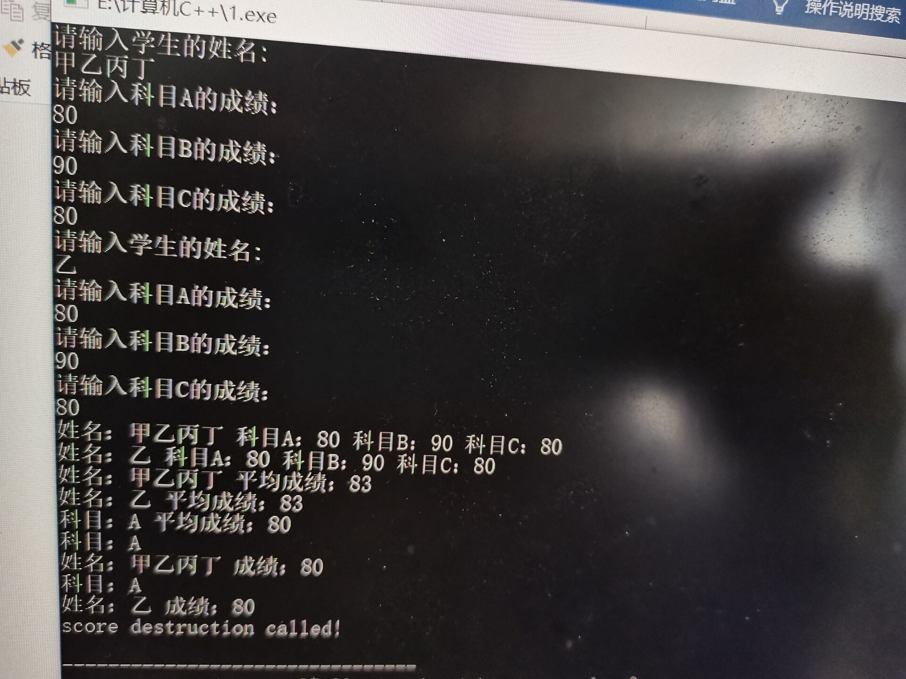

**二感想心得**

此次上机所遇到的问题是：

程序所需要完成的要求有点多，编写程序时不能很好地处理数据之间的关系；

对多维数组的相关知识有些遗忘，不过很快通过以前的笔记想了起来；

float和double都是关于数字的数据类型，不能定义字符串，字符串应该用string数据类型

**Copyright 2021-2099 XiaowenRen. All rights reserved**